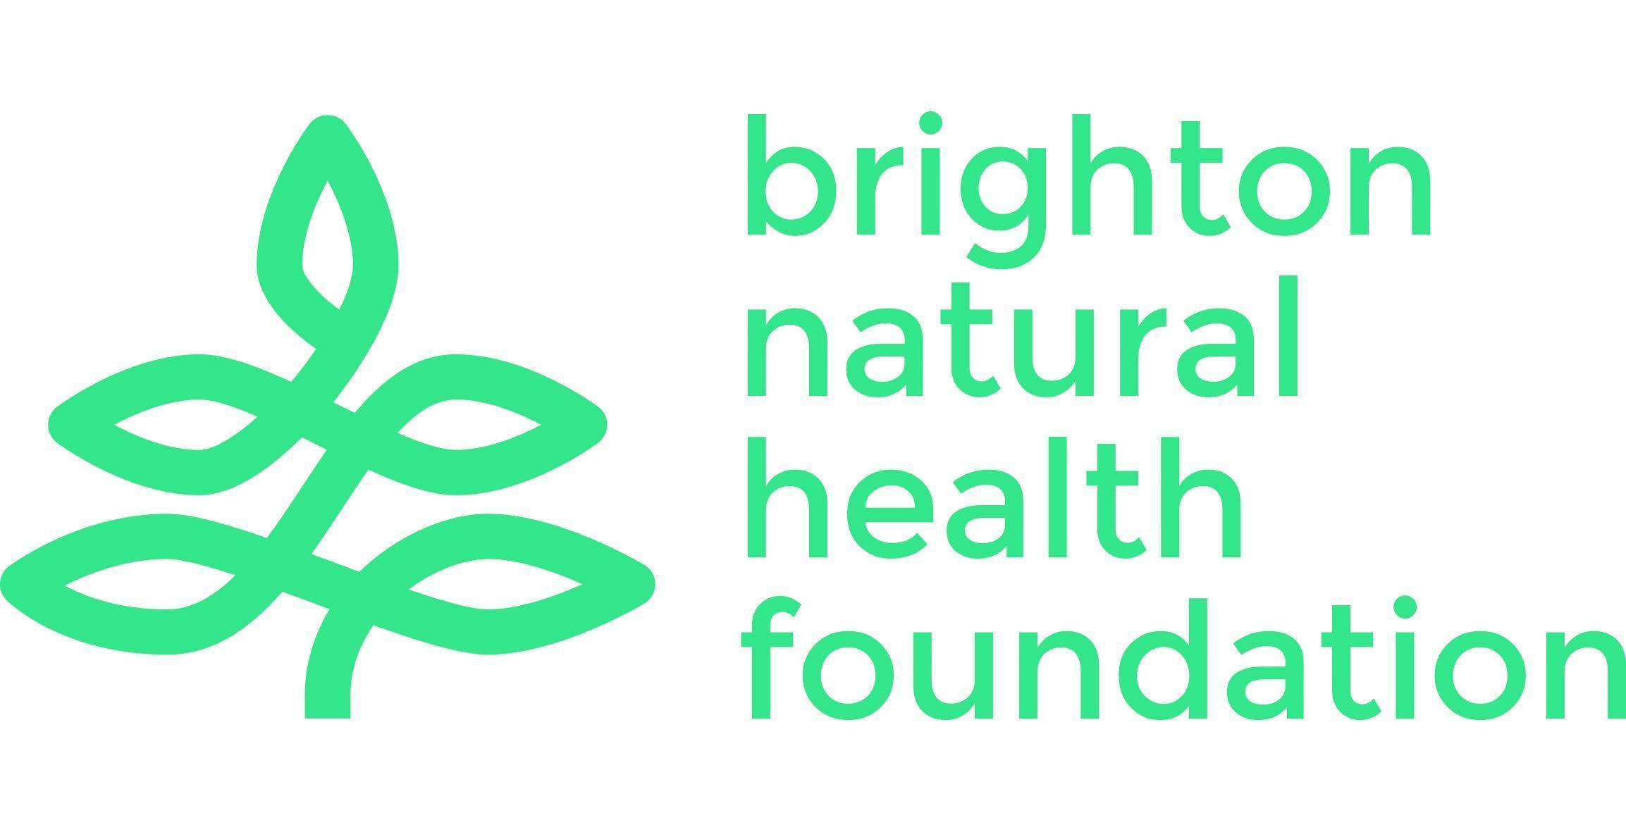
Brighton Natural Health Foundation Limited
Community Base 113 Queens Road Brighton BN1 3XG
hello@bnhf.org | www.bnhf.org
company no. 1836964
registered charity no. 290122

Fundraising Trustee
Location: Brighton – online/hybrid or in-person meetings
Role type: Trustee – voluntary position
Time commitment: Around 4-5 hours per month on average
Term of office: Initial three years and can stand for re-election

About Brighton Natural Health Foundation
Brighton Natural Health Foundation (BNHF) is a charity dedicated to improving community wellbeing in Brighton & Hove. We provide free, accessible mindful movement classes for people facing the greatest health inequalities, including yoga, qigong and Pilates. We are passionate about empowering people and communities to embrace mindful movement for a happier and healthier lifestyle.

Over the last 18 months we have been on a journey of change and transformation to ensure that we are a resilient and sustainable charity, able to develop and adapt. With a team of trustees, BNHF Director and staff already in place, we are seeking new trustees with specialist experience and knowledge to guide us through our next chapter. You will be joining BNHF at an exciting time as we embark on our strategy for the next few years.

Role Description
The role of the Fundraising Trustee is to provide strategic leadership on fundraising, helping the Board and team develop sustainable income streams for both project costs and core costs. This would suit someone with professional fundraising experience or significant knowledge of income generation, partnerships, or charity development, and who wants to apply their expertise to a values-led organisation.

You will be joining a committed, experienced and skilled Board of Trustees and a dynamic and forward-looking organisation, and with the opportunity and ability to influence our future. You would head up our Finance and Fundraising Committee Sub-committee and work with the BNHF Director, the Board and external bookkeeper to ensure that BNHF operates ethically, transparently, and in line with best practice, in all financial matters.

Our Board makes key decisions about the direction of the organisation and how we achieve our purpose. They also make sure that BNHF has the resources and policies it needs to do this well and to comply with its statutory obligations. We are looking for an active and engaged trustee who can provide the guidance needed to achieve our ambitions and help champion our mission to the outside world.

If you share our enthusiasm for tackling health inequalities, developing mental, physical and social health in the community, enjoy thinking strategically and working collaboratively, and can bring your professional and personal experience to our Board, then we’d love to hear from you.

Role Details
Working with the Board, the Treasurer and the BNHF Director, key aspects of the role include to:

Fundraising Strategy & Oversight
- Guide the development of a diverse fundraising strategy across grants, individual giving, corporate partnerships, community fundraising, and events
- Advise the Board on priorities, opportunities, and risks related to income generation
- Help identify new funding prospects and develop/strengthen relationships with funders
- Help with the development of the annual budget and advise on long-term financial planning
- Sit on the Finance & Fundraising Sub-committee

Grant Funding & Trusts
- Support the writing and reviewing of grant applications
- Advise on project design, budget alignment, impact reporting, and evaluation requirements for funders
- Help ensure compliance with grant conditions and timely reporting
Community & Corporate Fundraising
- Assist the team in developing relationships with local businesses, community groups, and partners
- Provide insight into events / campaigns / initiatives that can increase support from the local community

Governance, Ethics & Compliance
- Ensure fundraising follows best practice and meets charity and Fundraising Regulator guidelines
- Promote ethical fundraising and protect beneficiary dignity and data
- Help monitor risk and financial sustainability related to income generation

Trustee Responsibilities (all trustees)
- Attend and actively participate in Board and relevant sub-committee meetings
- Provide constructive challenge, oversight and support to the senior team
- Act in the best interests of the charity and its beneficiaries
- Promote the charity externally and help build a strong, positive reputation

Skills & Experience
You don’t need to have specific previous experience on a charity board to apply for this. We recognise that many of the skills and experience required are transferable, and you may have gained them in other settings or through other relevant experience. These include:

Essential
- Professional experience in fundraising or income generation / business development / partnerships
- Understanding of charity fundraising principles and best practice
- Strategic thinker with the ability to advise the board on sustainable income growth
- Strong communication skills and ability to build relationships
- Ability to listen and engage effectively
- Reliable, collaborative, and comfortable with challenge and debate
- Commitment to equity, inclusion and BNHF’s values, and Nolan’s seven principles of public life

Desirable
- Experience of bid-writing for grants and donations
- Experience as a trustee or board member, or of working in charities
- Knowledge of funders or community networks in the local area or beyond
- Understanding or experience of the mental, physical and social health sector

What you will gain from being a BNHF trustee
- An opportunity to use your professional skills to support community health and wellbeing
- A role in shaping the direction, resilience, and future of a meaningful local charity
- Being part of a supportive, collaborative team of trustees
- Experience in charity governance and strategic leadership

How to Apply
Please send a brief statement of interest and your CV to chair@bnhf.org. For an informal conversation
about the role, contact Peter Kinsey– peterkinsey@bnhf.org – 07738 034135‬.

