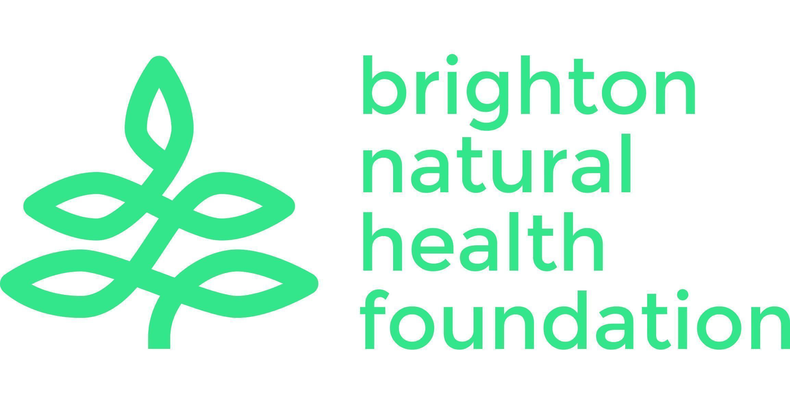
Brighton Natural Health Foundation Limited
Community Base 113 Queens Road Brighton BN1 3XG
hello@bnhf.org | www.bnhf.org
company no. 1836964
registered charity no. 290122

Board Secretary / Trustee
Location: Brighton – online/hybrid or in-person meetings
Role type: Trustee – voluntary position
Time commitment: Around 4-5 hours per month on average
Term of office: Initial three years and can stand for re-election

About Brighton Natural Health Foundation
Brighton Natural Health Foundation (BNHF) is a charity dedicated to improving community wellbeing in Brighton & Hove. We provide free, accessible mindful movement classes for people facing the greatest health inequalities, including yoga, qigong and Pilates. We are passionate about empowering people and communities to embrace mindful movement for a happier and healthier lifestyle.

Over the last 18 months we have been on a journey of change and transformation to ensure that we are a resilient and sustainable charity, able to develop and adapt. With a team of trustees, BNHF Director and staff already in place, we are seeking new trustees with specialist experience and knowledge to guide us through our next chapter. You will be joining BNHF at an exciting time as we embark on our strategy for the next few years.

Role Description
The Board Secretary plays a vital governance and organisational role in ensuring the smooth and effective running of the Board. You will support good communication, record-keeping, compliance, and timely decision-making, and ensure accurate minutes of meetings are recorded and circulated. This role would suit someone highly organised and committed to the mission and values of the charity.

You will be joining a committed, experienced and skilled Board of Trustees and a dynamic and forward-looking organisation, and with the opportunity and ability to influence our future. You would head up our Governance Sub-committee and work with the Chair, the Board and the BNHF Director to ensure that BNHF operates ethically, transparently, and in line with best practice.

Our Board makes key decisions about the direction of the organisation and how we achieve our purpose. They also make sure that BNHF has the resources and policies it needs to do this well and to comply with its statutory obligations. We are looking for an active and engaged trustee who can provide the guidance needed to achieve our ambitions and help champion our mission to the outside world.

If you share our enthusiasm for tackling health inequalities, developing mental, physical and social health in the community, enjoy thinking strategically and working collaboratively, and can bring your professional and personal experience to our Board, then we’d love to hear from you.

Role Details
Working with the Chair and Governance Trustee in particular, key aspects of the role include to:

Board Administration
- Organise and schedule Board and committee meetings in consultation with the Chair
- Prepare and circulate agendas, papers, and relevant documents ahead of meetings
- Ensure trustees have the information they need to make informed decisions

Minutes & Records
- Take accurate, impartial minutes of Board meetings, capturing decisions, actions, and key discussions
- Ensure follow-up on action points and maintain clear records of progress
- Maintain and update statutory records, including registers of trustees’ details
Governance & Compliance
- Support the Chair and Governance Trustee in ensuring compliance with regulatory requirements
- Help uphold good governance and support the charity’s long-term sustainability
- Assist with preparing the Annual Report and submitting the annual return
- Help keep governance policies, procedures, and the governing document up to date
- Manage trustee induction processes and maintain trustee files
Communication & Coordination
- Act as a central coordination point for Board communication
- Ensure clear, timely communication between trustees, staff, volunteers, and partners
- Support internal governance projects, such as board reviews or strategy updates
Trustee Responsibilities (all trustees)
- Attend and participate in Board and relevant sub-committee meetings
- Provide constructive challenge, oversight and support to the senior team
- Act in the best interests of the charity and its beneficiaries
- Promote the charity externally and help build a strong, positive reputation

Skills & Experience
You don’t need to have specific previous experience on a charity board to apply for this. We recognise that many of the skills and experience required are transferable, and you may have gained them in other settings or through other relevant experience. These include:

Essential
- Strong organisational and administrative skills
- Ability to write clear, accurate minutes and communicate effectively
- Comfortable managing documents, deadlines, and processes
- Reliable, detail-oriented, and discreet with sensitive information
- Ability to listen and engage effectively
- Reliable, collaborative, and comfortable with challenge and debate
- Commitment to equity, inclusion and BNHF’s values, and Nolan’s seven principles of public life

Desirable
- Experience in governance, administration, charity work, or board support
- Knowledge of charity law or regulatory requirements
- Experience of policy or document management
- Experience as a trustee or board member, or of working in charities
- Understanding or experience of the mental, physical and social health sector

What you will gain from being a BNHF trustee
- An opportunity to use your professional skills to support community health and wellbeing
- A role in shaping the direction, resilience, and future of a meaningful local charity
- Being part of a supportive, collaborative team of trustees
- Experience in charity governance and strategic leadership

