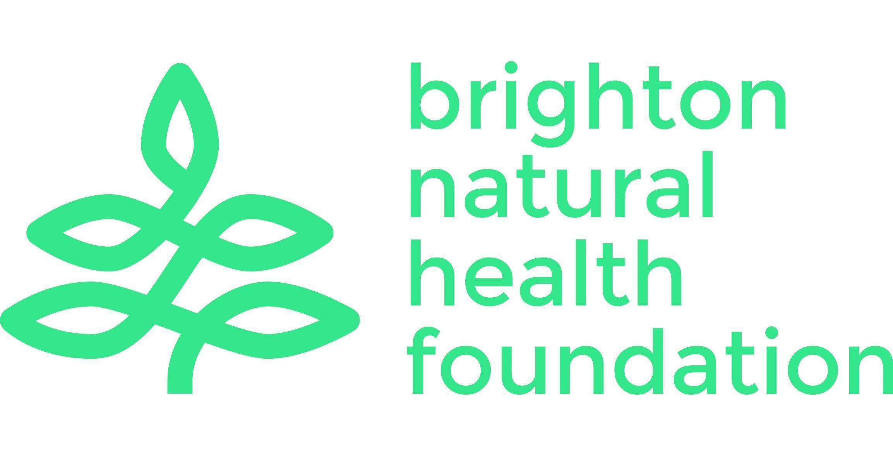
Brighton Natural Health Foundation Limited
Community Base 113 Queens Road Brighton BN1 3XG
hello@bnhf.org | www.bnhf.org
company no. 1836964
registered charity no. 290122

Governance / Legal Trustee
Location: Brighton – online/hybrid or in-person meetings
Role type: Trustee – voluntary position
Time commitment: Around 4-5 hours per month on average
Term of office: Initial three years and can stand for re-election

About Brighton Natural Health Foundation
Brighton Natural Health Foundation (BNHF) is a charity dedicated to improving community wellbeing in Brighton & Hove. We provide free, accessible mindful movement classes for people facing the greatest health inequalities, including yoga, qigong and Pilates. We are passionate about empowering people and communities to embrace mindful movement for a happier and healthier lifestyle.

Over the last 18 months we have been on a journey of change and transformation to ensure that we are a resilient and sustainable charity, able to develop and adapt. With a team of trustees, BNHF Director and staff already in place, we are seeking new trustees with specialist experience and knowledge to guide us through our next chapter. You will be joining BNHF at an exciting time as we embark on our strategy for the next few years.

Role Description
The role of the Governance & Legal Trustee is to strengthen BNHF’s governance structures, ensure compliance with its statutory duties, and help the Board fulfil its obligations to the communities we serve. This would suit someone with experience in law, governance, risk, or regulatory compliance who wants to apply their expertise to a values-led organisation.

You will be joining a committed, experienced and skilled Board of Trustees and a dynamic and forward-looking organisation, and with the opportunity and ability to influence our future. You would head up our Governance Sub-committee and work with the Chair, the Board and the BNHF Director to ensure that BNHF operates ethically, transparently, and in line with best practice.

Our Board makes key decisions about the direction of the organisation and how we achieve our purpose. They also make sure that BNHF has the resources and policies it needs to do this well and to comply with its statutory obligations. We are looking for an active and engaged trustee who can provide the guidance needed to achieve our ambitions and help champion our mission to the outside world.

If you share our enthusiasm for tackling health inequalities, developing mental, physical and social health in the community, enjoy thinking strategically and working collaboratively, and can bring your professional and personal experience to our Board, then we’d love to hear from you.

Role Details
Working with the BNHF Director and the Board, key aspects of the role include to:

Governance Oversight
- Ensure the charity complies with its governing document, charity law and other relevant legislation
- Provide advice on governance best practice, helping the Board maintain high standards of accountability and transparency
- Support periodic reviews of governance policies and the effectiveness of the Board
- Act as chair of the Governance Sub-committee

Legal & Regulatory Compliance
- Advise on legal matters relating to contracts, partnerships, safeguarding, data protection (GDPR), employment and risk
- Help oversee the charity’s risk management processes, identifying legal or regulatory risks and advising on mitigation
- Ensure timely completion of regulatory filings and returns (in collaboration with the Board Secretary and Treasurer)

Policy & Documentation
- Review and maintain key governance documents, including policies, codes of conduct and trustee agreements
- Ensure appropriate systems are in place for document management and record-keeping
- Advise on updates to the constitution or governing document if required

Strategic Support
- Contribute to the development of strategy, bringing a governance and legal perspective to decision-making
- Support due diligence and compliance for new projects, funding, or partnerships
- Champion ethical practice and organisational integrity

Trustee Responsibilities (all trustees)
- Attend and actively participate in Board and relevant sub-committee meetings
- Provide constructive challenge, oversight and support to the senior team
- Act in the best interests of the charity and its beneficiaries
- Promote the charity externally and help build a strong, positive reputation

Skills & Experience
You don’t need to have specific previous experience on a charity board to apply for this. We recognise that many of the skills and experience required are transferable, and you may have gained them in other settings or through other relevant experience. These include:

Essential
- Professional experience in law, governance, compliance, contracts, or related fields
- Ability to interpret legal and regulatory information and communicate clearly to non-specialists
- Understanding of risk management and ethical governance
- Ability to listen and engage effectively
- Reliable, collaborative, and comfortable with challenge and debate
- Commitment to equity, inclusion and BNHF’s values, and Nolan’s seven principles of public life

Desirable
- Knowledge of charity law or working with charitable organisations
- Understanding of data protection, safeguarding and/or employment law
- Experience as a trustee or board member, or of working in charities
- Understanding or experience of the mental, physical and social health sector

What you will gain from being a BNHF trustee
- An opportunity to use your professional skills to support community health and wellbeing
- A role in shaping the direction, resilience, and future of a meaningful local charity
- Being part of a supportive, collaborative team of trustees
- Experience in charity governance and strategic leadership

How to Apply
Please send a brief statement of interest and your CV to chair@bnhf.org. For an informal conversation
about the role, contact Peter Kinsey– peterkinsey@bnhf.org – 07738 034135‬.

